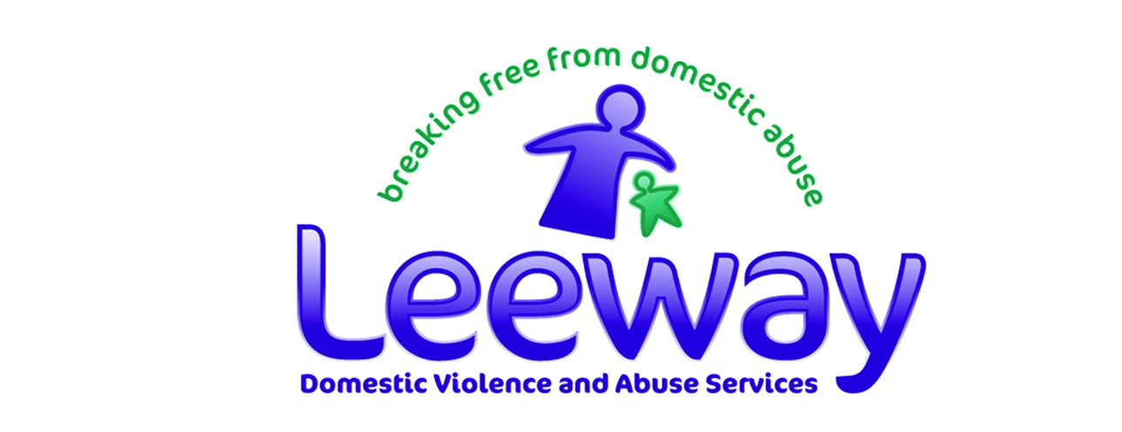
Training Booking Form

Please write clearly in capital letters

Training
Date | Day - date - year |  | Facilitator
Time

Training will be held at: | Lower Ground Floor  79 Thorpe Road  Norwich  NR1 1UA |  |  | The car park is behind 79 Thorpe Road, off Cremorne Lane

Organisation details
Organisation name | Office Use Only  ---------/---------/------  Booked:  Confirmed:  Paid:
Contact name

Address

Telephone

Email

Invoice name and address (if different from above) and your purchase order number

Booking Details
Name of person attending

Special access requirements (please tick) | Loop system Disabled access  Other (please state)
Any special dietary requirements? | vegetarian vegan  gluten free other (please state)

Continued…/

Terms and conditions

I understand/agree that:

- This training does not enable me to train others to be facilitators.

- All materials are copyrighted to ©Leeway and will not be used without the written permission of Leeway.

- The Trainer reserves the right to refuse to train anyone who does not behave in a pleasant and cooperative manner

Cancellation by the attendee

If the attendee cancels their place on the training, the following charges will apply:

- Cancellation notified to us more than 5 working days before the training date: no charge
- Cancellation notified to us between 1 and 4 working days before the training date: 50% of the charge
- Cancellation notified to us less than 24 hours before the training date: 100% of the charge

Cancellation by Leeway

In the unlikely event that Leeway cancels this training (for example because of unforeseen and unavoidable building maintenance activity, or because of severe weather) a cancellation charge will not apply.

Signed:

Print name:

Date:

Please return this form by email, post or fax to:

Training, Leeway Domestic Violence and Abuse Services, PO Box Leeway, City Hall, Norwich, NR2 1NH

Email: admin@leewaynwa.org.uk or Fax: 01603 623772

